|  |  |  |  |  |
| --- | --- | --- | --- | --- |
| Student Name | James Eastman | Student Number | | 467513560 |
| Unit Code/s & Name/s | ICTNWK539 Design and implement integrated server solutions  ICTNWK540 Design, build and test network servers | | | |
| Cluster Name  *If applicable* | Server | | | |
| Assessment Name | Implementing Server Solutions | Assessment Task No. | | 3 of 3 |
| Assessment Due Date |  | Date submitted | | / / |
| Assessor Name | Frans De Jong | | | |
| **Student Declaration:** I declare that this assessment is my own work. Any ideas and comments made by other people have been acknowledged as references. I understand that if this statement is found to be false, it will be regarded as misconduct and will be subject to disciplinary action as outlined in the TAFE Queensland Student Rules. I understand that by emailing or submitting this assessment electronically, I agree to this Declaration in lieu of a written signature. | | | | |
| Student Signature |  | | Date | / / |

|  |  |
| --- | --- |
| **Instructions to Student** | General Instructions:  This practical observation will be based on the two (2) integrated server designs that you have created in Assessment Task 2 Part 1.  You are required to implement both server design option that you created in Assessment Task 2 and demonstrate to the teacher.  A risk assessment has to be done before the implementation of servers.  After successful practical implementation, you need complete the relevant documentation and submit them to connect.  Refer to the detail instructions given further down in this document. |

|  |  |
| --- | --- |
|  | Materials to be supplied:  Your teacher will allocate access to physical and/or virtual technology to complete this practical tasks  If you are not using physical machines to install servers you could use virtual machines to simulate the physical servers. The following technology will be available for you to build your servers.  VMware Workstation/VMware Workstation Player /Oracle Virtual Box  Microsoft Hyper-V (On Windows 2019 servers) / VMware ESXi  The documentation templates can be downloaded from Connect.  Work, Health and Safety:  TAFE Queensland student rules are designed to ensure that learners are aware of their rights as well as their responsibilities. All learners are encouraged to familiarise themselves with the TAFE Queensland student rules, specifically as they relate to progress of study and assessment guidelines.  Student rules: <http://tafeqld.edu.au/current-students/student-rules/>  Assessment Criteria:  To achieve a satisfactory result, your assessor will be looking for your ability to demonstrate your implementation of both server design options and complete all the documentation.  Time Allowed:  Observation will occur over 2 to 3 half day sessions. |
| **Submission details** (if relevant) | **Due:** Week 8  Insert your details on page 1 and sign the Student Declaration. Include this form with your submission.  Submit the listed files below as per the instructions in the Connect online learning system.  You are to submit the following files:  ICTNWK539_540_Risk_Assessment_yourname.docx  ICTNWK539_540_Test_Plan_yourname.docx  ICTNWK539_540_Trouble_shooting_yourname.docx  ICTNWK539_540_Report_yourname.docx  Assessment to be submitted via  TAFE Queensland Learning Management System (Connect): [*https://connect.tafeqld.edu.au/d2l/login*](https://connect.tafeqld.edu.au/d2l/login)  Username; 9 digit student number  For password resets go to: [*https://passwordreset.tafeqld.edu.au/default.aspx*](https://passwordreset.tafeqld.edu.au/default.aspx) |
| **Instructions to Assessor** | Student will require:  Computer applications currently used in industry  Support resources, including online, manuals and training booklets  A computer system with a suitable current OS and access to the internet  Work, Health and Safety:  TAFE Queensland student rules are designed to ensure that learners are aware of their rights as well as their responsibilities. All learners are encouraged to familiarise themselves with the TAFE Queensland student rules, specifically as they relate to progress of study and assessment guidelines.  Student rules: <http://tafeqld.edu.au/current-students/student-rules/>  Level of Assistance:  Teachers and tutors should be available in class, and accessible by email for students working from home. Staff cannot directly show students answers but guide them to where to go to complete tasks individually. The teacher will make reasonable adjustment for students, as and when appropriate, after consultation with the Disability and Counselling team.  Assessment Criteria:  See Marking Criteria on Connect  Assessors of this unit must satisfy the requirements for assessors in applicable vocational education and training legislation, frameworks and/or standards.  Assessors of this unit must satisfy the requirements for assessors in applicable vocational education and training legislation, frameworks and/or standards. |
| **Note to Student** | An overview of all Assessment Tasks relevant to this unit is located in the Unit Study Guide. |

# Instructions to Student

In this assessment you will do the following tasks in both server design implementation options:

1. Risk Assessment

Complete the risk assessment, **ICTNWK539_540_Risk_Assessment_Template.docx**, before you start network installation at the Anzac Airport work site.

Save the document as:

**ICTNWK539_540_Risk_Assessment_yourname.docx**

1. Server and workstation Installation
   1. Observed all WHS policy and procedures for the work site
   2. Obtain an industry standard physical servers or create virtual servers with industry standard specifications
   3. Install Windows 2019 Operating system and at least one other OS

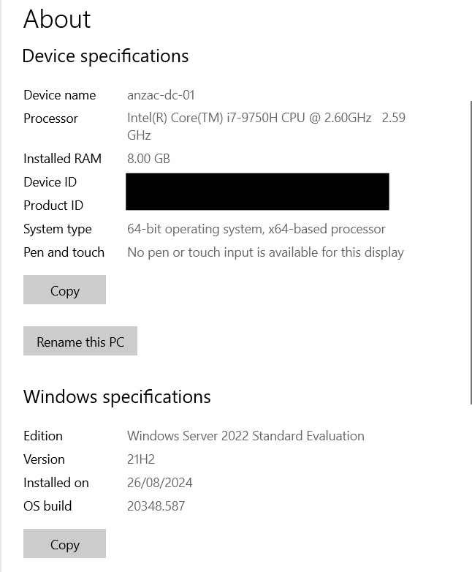

Win 22 Server DC-01 installed

* 1. Connect at least one server to the internet using existing switch and network infrastructure
  2. Install applications at least in one server or update at least one server OS from the internet
  3. Install and configure a physical/virtual desktop workstation that will be part of the domain

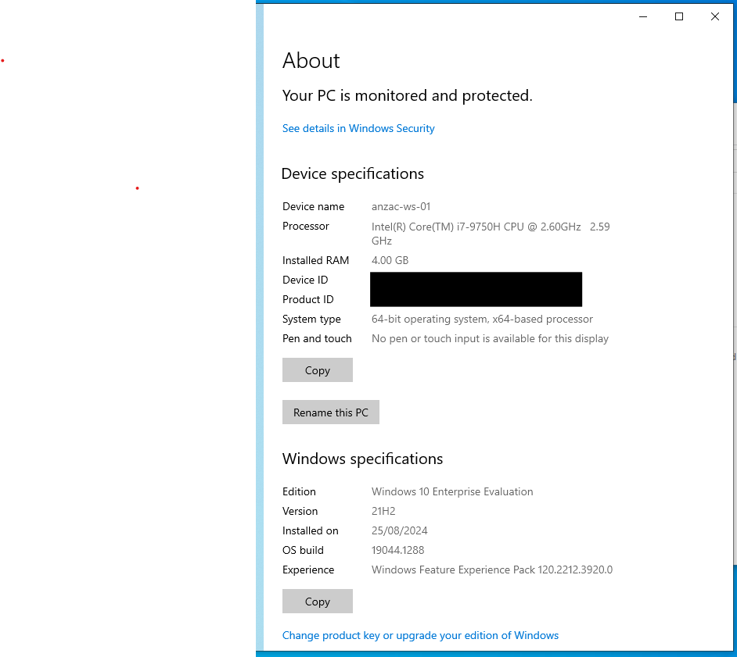

Windows10 Workstion installed

* 1. Configure IP addresses on all the servers and workstation and connect them to a network using physical or virtual switch

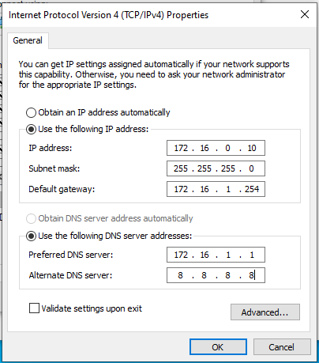

Windows 10 Worksation IP

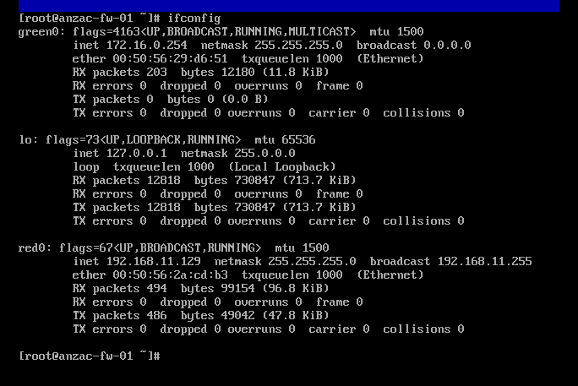

IpFire Firewall IP config.

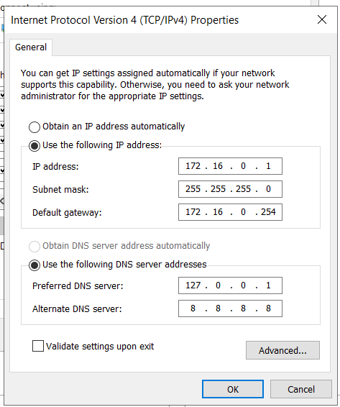

Win 22 Server DC-01 IP Config.

1. Server Configuration
2. Install Active directory and create domain controller. Use <your_first_name>anzac.com as the domain name. (e.g. tonyanzac.com)

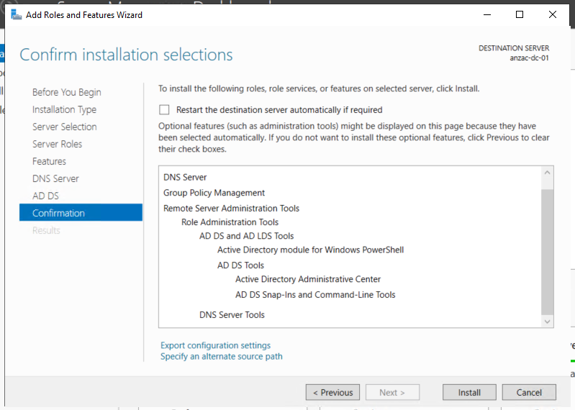

DNS and AD DS installed anzac-dc-01

b) Join all the servers including Non Windows servers to the domain

c) Join Workstation to the domain

d) Create Active directory OUs, users (at least 2) and groups according to your design

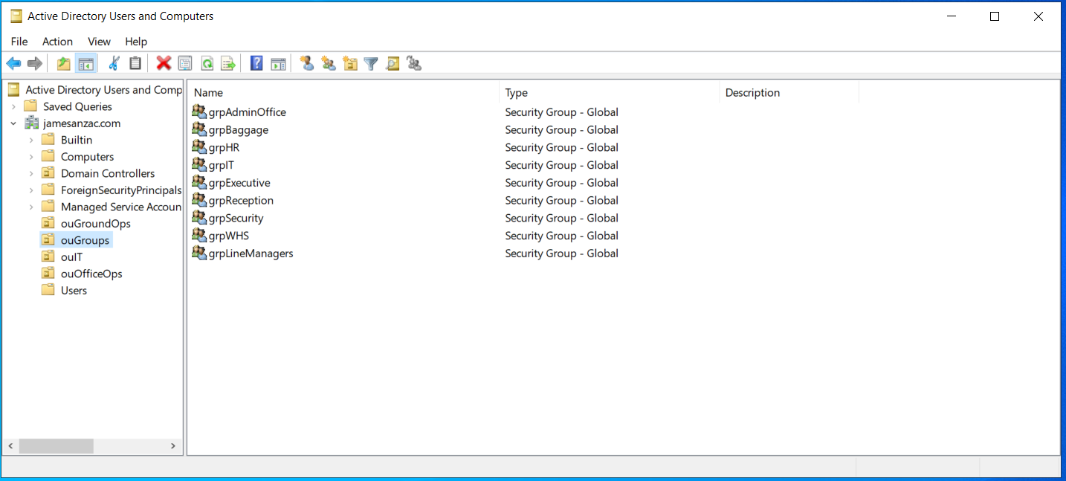

User Groups and Operational Units

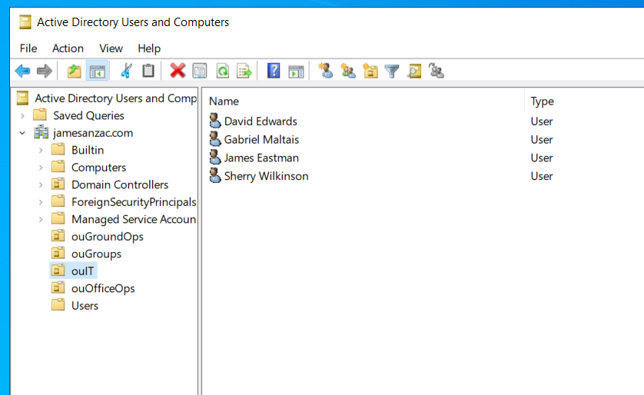

IT OU with users

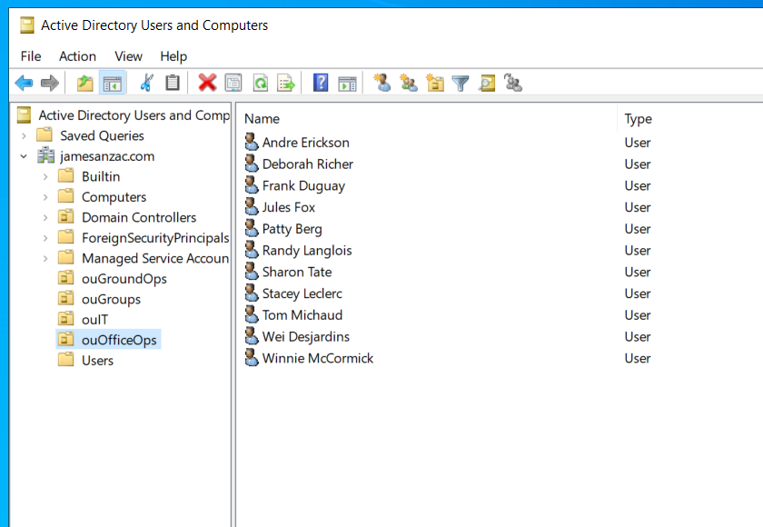

OfficeOps OU with users

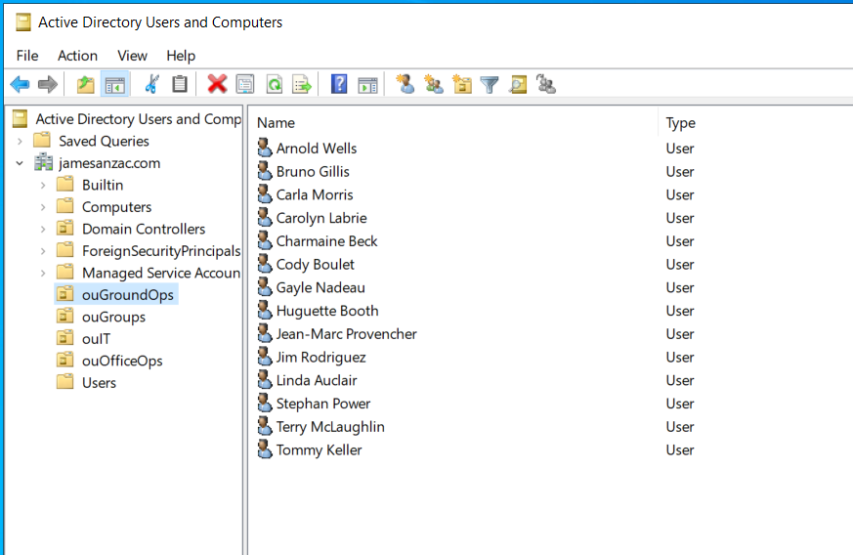

Ground Ops with users

e) Configure the following network services according to your design options

* 1. DHCP

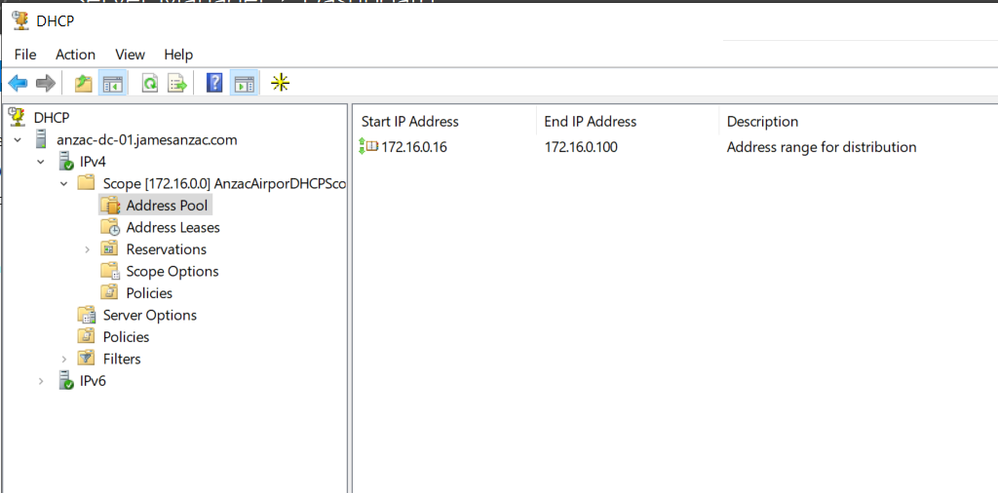

DHCP Setup

* 1. DNS

Primary & Backup DNS Server

* 1. Windows server Update Services (WSUS) to auto update

WSUS Setup

* 1. Backup and restore (Backup and restore storage volume)
  2. Folder structure and assign permission according to the design
  3. Windows Firewall to disable ping and Linux firewall to enable communication with application
  4. File/Folder sharing between different server platforms
  5. Install printers and deploy them using group policies
  6. Proxy Server
  7. NTP server
  8. Configure following applications according to your design options

i. WEB

ii. Mail

iii. FTP

iv. Diagnostic software

1. Testing and Troubleshooting

Conduct the following tests and document issues in the test plans **ICTNWK539_540_Test_Plan_yourname.docx** which you created in Assessment Task 2. Submit the completed document to connect.

a) Connectivity tests

i. Test connectivity of integrated servers by using the ping command from the desktop (before and after disabling by the firewall)

ii. Test Email by sending and receiving mail

iii. Test WEB connectivity

iv. Test FTP with large files and concurrent users

v. Test login from non-Windows server with an AD user that you created

b) Performance tests

i. Test and monitor performance of each server using industry recognised network utilities

ii. Run installed diagnostic software and produce a report

c) Availability tests

i. Test system and data availability according to file/folder permission specified in your design document

ii. Test folder sharing between different server platforms

iii. Back up a Windows storage volume and restore in another server

d) Diagnose and troubleshoot any integration problems

i. Analyse the issues you documented in issues in the test plans ICTNWK539_540_Test_Plan_yourname.docx and identify the issues

ii. Diagnose the errors, resolve them and document them in ICTNWK539_540_Trouble_shooting_Template.docx Rename the document ICTNWK539_540_Trouble_shooting_yourname.docx before submitting to connect

iii. Test the changes made to correct the issues to check if they comply with your design.

1. Post installation Tasks

a) Document the server configuration and status in ICTNWK539_540_Report_Template.docx Rename the document ICTNWK539_540_Report_yourname.docx before submitting to connect

b) Write an email to address the following. Write the email at the end of the document ICTNWK539_540_Report_yourname.docx

i. To convey the status of servers (as a report you created)

ii. Sign off

iii. Clean-up and restoration of worksite to client’s satisfaction

You are to complete and submit the following files:

* ICTNWK539_540_Risk_Assessment_yourname.docx
* ICTNWK539_540_Test_Plan_yourname.docx
* ICTNWK539_540_Trouble_shooting_yourname.docx
* ICTNWK539_540_Report_yourname.docx